The laboratory work 7

Exercise 1: Below are the two lists convert it into the dictionary
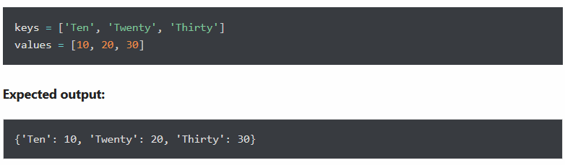

Exercise 2: Merge following two Python dictionaries into one
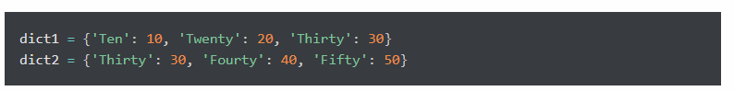
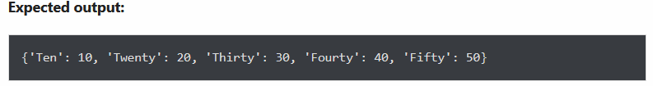

Exercise 3: Access the value of key ‘history’ from the below dict
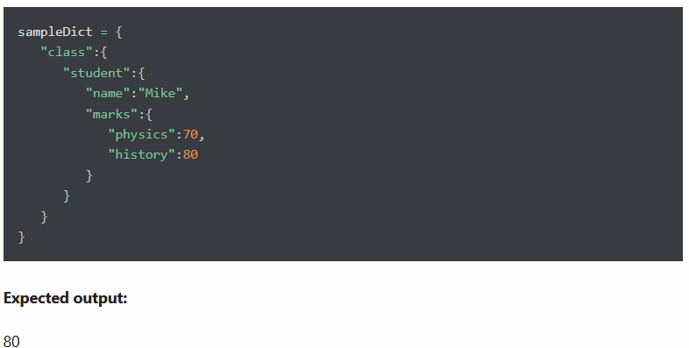

Exercise 5: Create a new dictionary by extracting the following keys from a below dictionary
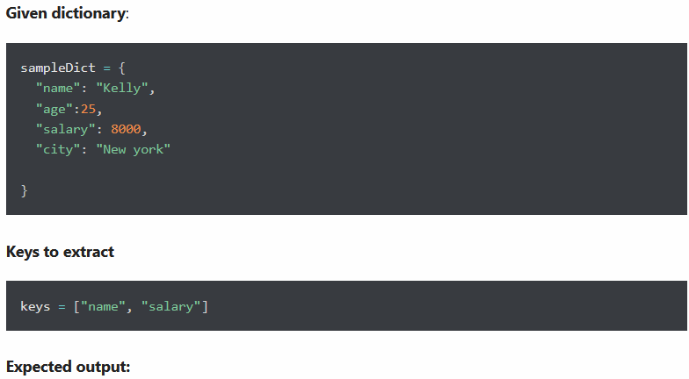

Exercise 7: Check if a value 200 exists in a dictionary
Expected output:
True

Exercise 8: Rename key city to location in the following dictionary
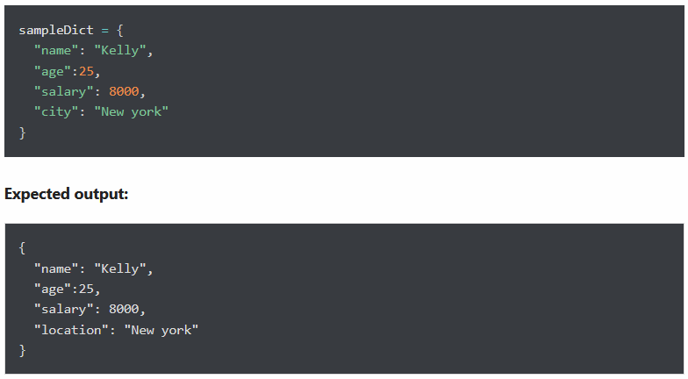

Exercise 9: Get the key of a minimum value from the following dictionary

Exercise 10: Change Brad’s salary to 8500 from a given Python dictionary
